Data Analysis Report

School Analysis

Following is the summary of analyses of City School. Conclusions are followed by summary tables.

## Analysis of Scores by schools spending

1. As per following data we can see that schools with less budget per student have performed better overall.
2. There is difference of almost 30% in the Overall Passing rate between schools with less per capita budget vs ones with higher per capita budget.
3. We can also observe that disparity in performance is largely attributed to % passing rate for Math.

## Analysis of scores by School size

1. From the following data we can see that small (<1000 Student) and medium (1000-2000 Student) sized schools have far outperformed large schools (2000-5000.
2. There is almost 30% difference in performance of small & medium vs large schools.
3. We can observe that % passing rate for Math drops significantly when school has more than 2000 students.

## Analysis of scores by School Type

1. From the following data frame Charter schools performed well than District Schools.
2. Charter schools are performing much better than district schools in both Math and reading

Number of Students by School Type

1. Number of students in district schools is much higher than charter schools.

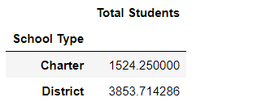

## Per Capita Budget by School Type

1. Per capita budget in District schools is marginally higher than Charter schools
2. While District schools handle more students, per capita budget is almost same as Charter schools. This suggests that difference in performance of District schools as compared to Charter schools can be attributed to school practices.

